**Project Report**

**1.INTRODUCTION**

**overview**

Wedding photography is a specialized field of photography that focuses on capturing the moments, emotions, and memories of a couple's wedding day. It's a visually and emotionally rich genre of photography that involves documenting the joy, love, and celebration of one of the most important days in a person's life. Here is an overview of wedding photography:

**Key Aspects of Wedding Photography:**

**Storytelling:**

Wedding photography is about telling the unique story of a couple's wedding day. It involves capturing the narrative, from the preparations and ceremony to the reception and all the candid moments in between.

**Documentary Style:**

Many modern wedding photographers use a documentary or photojournalistic style, focusing on candid shots that authentically reflect the emotions and interactions of the day.

**Portraiture:**

Wedding photographers also specialize in creating beautifully composed and lit portraits of the couple, their families, and bridal parties.

**Challenges and Unpredictability:**

Wedding photographers must be adaptable and skilled in various lighting conditions, working quickly and unobtrusively to capture fleeting moments.

**Key Responsibilities of a Wedding Photographer:**

**Pre-Wedding Planning**:

Consult with the couple to understand their vision, preferences, and specific shot requirements.

**Equipment and Technical Expertise:**

Ensure you have the right photography equipment, including camera bodies, lenses, and lighting, and possess the technical skills to use them effectively.

**Candid Moments:**

Capture authentic and emotional candid moments, such as the exchange of vows, laughter, and tears.

**Formal Portraits:**

Create beautifully posed and well-lit formal portraits of the couple, their families, and bridal parties.

**Editing and Post-Processing:**

Process and edit the images to enhance their quality and maintain a consistent style.

**Client Communication:**

Maintain clear and open communication with the couple to manage expectations and address any concerns.

**Business Management**:

Handle the business aspects of wedding photography, including contracts, scheduling, and financial matters.

**Delivery and Presentation:**

Deliver the final images in a manner that exceeds the couple's expectations, whether through digital galleries, prints, or albums.

**Purpose**

Wedding photography tells the unique love story of the couple. It captures the essence of their relationship, from the engagement to the wedding day, allowing them to share their narrative with family and friends.

**Problem Definition & Design Thinking**

**Empathy map**

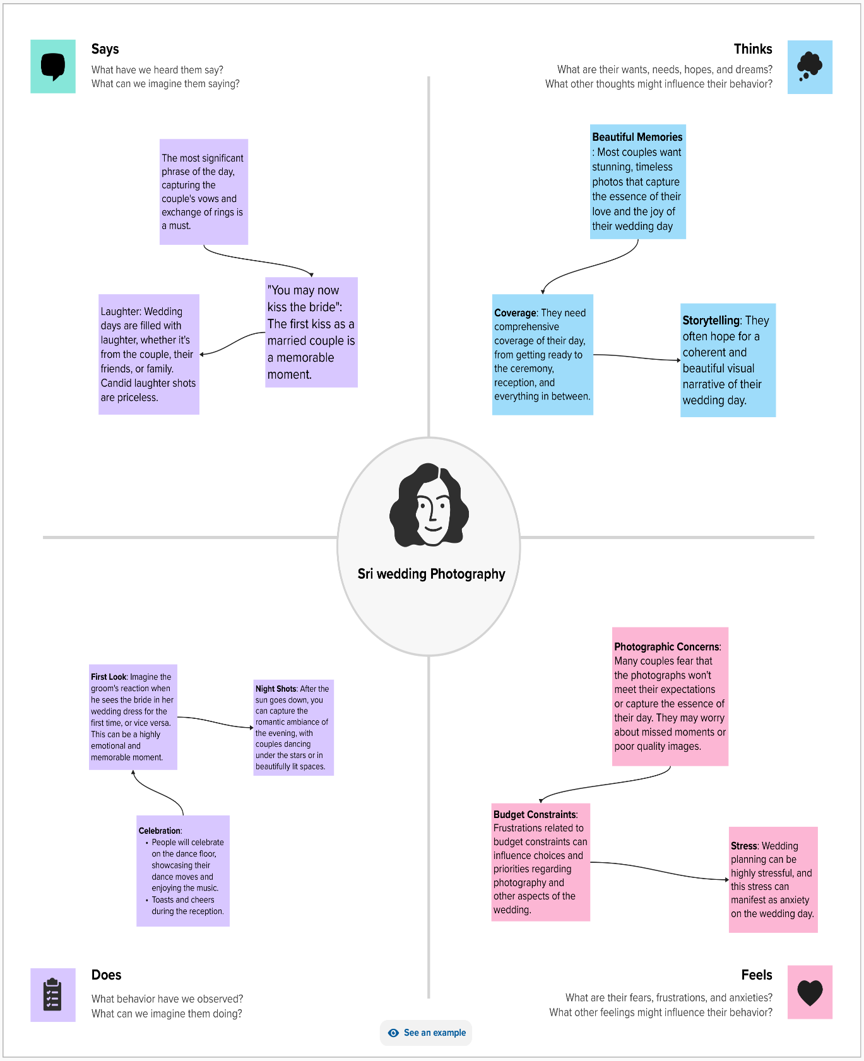

**Ideation & brainstorming map**

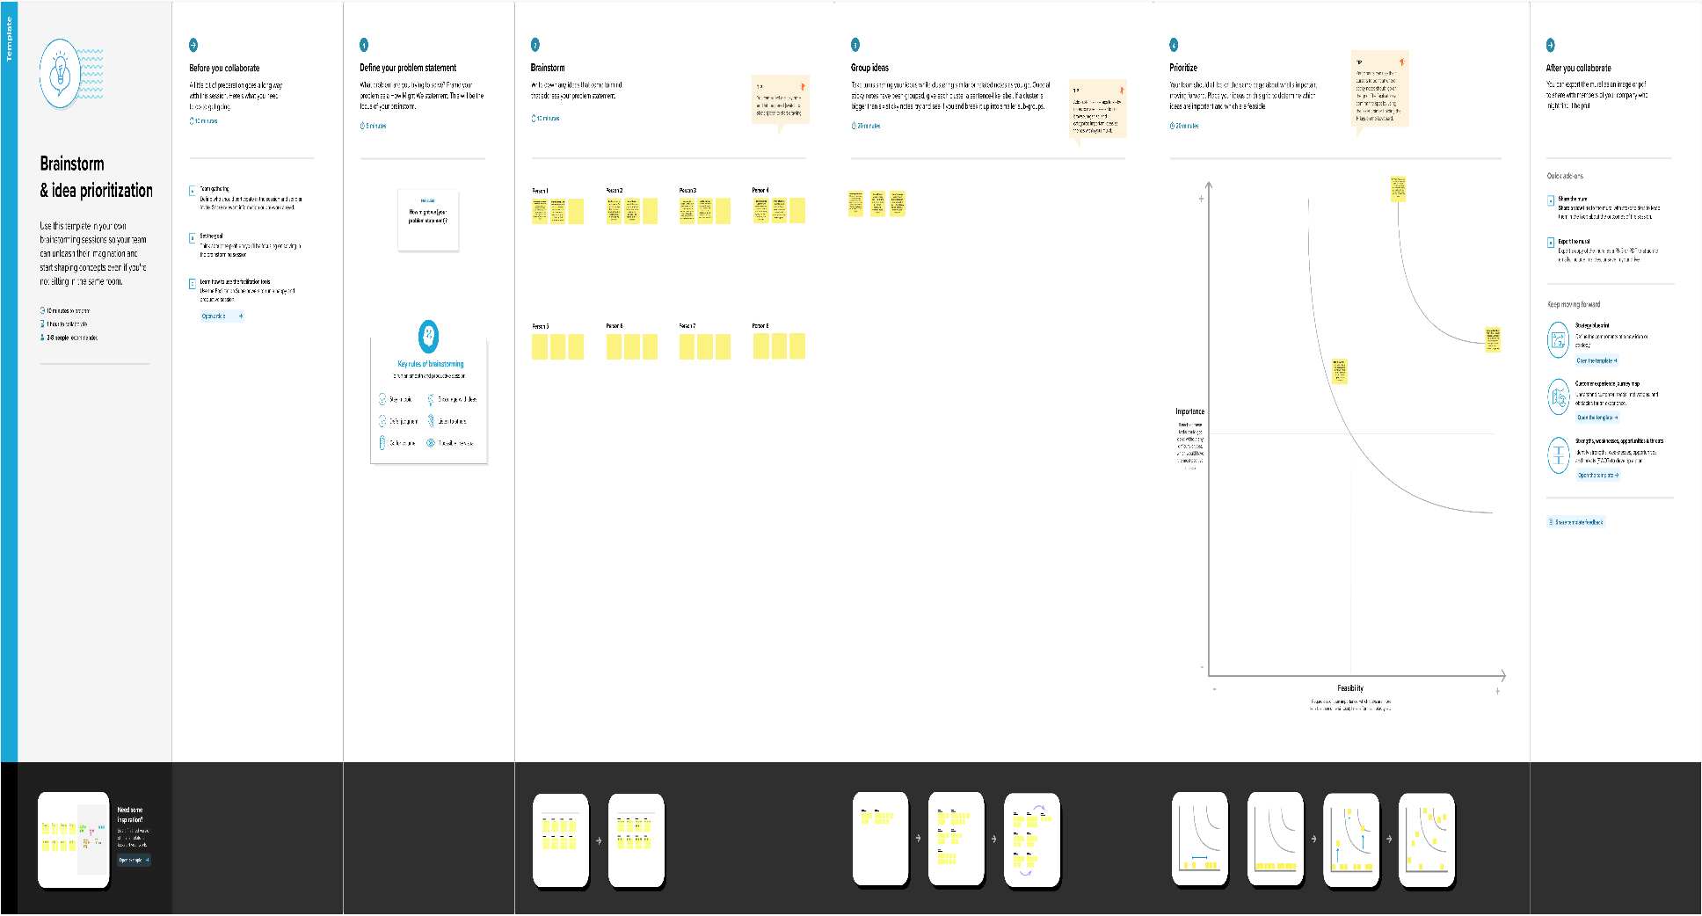





**Advantages & Disadvantages**

**Advantage:**

1.Capture Precious Moments

2. Reliving the Day

3. Share with Loved Ones

**Disadvantage:**

1.Long Hours

2. Unpredictable Conditions

3. High Expectations

**Applications**

1. Wedding Albums and Prints
2. Digital Galleries
3. Engagement Sessions
4. Pre-Wedding Planning

**Conclusion**

Wedding photographers have the privilege of being both artists and documentarians, creatively expressing the essence of each couple while preserving their cherished moments for generations to come. This profession comes with its challenges and responsibilities, from managing client expectations to adapting to unpredictable conditions, but the rewards are immeasurable.